Poll Release Email and Social Content

Timing: NCECF to send around 9 a.m. on the release day
NCECF Email

Subject Line: STATE POLL RESULTS: North Carolinians are ready for the state to do more.

Email Copy:
A new, bipartisan poll commissioned by the North Carolina Early Childhood Foundation shows that voters across the political spectrum are united on making quality, birth-to-age-eight early education a top priority for the state. In fact, 80% of voters support doubling investment in early education—an annual increase in state funding from 1% to 2%.

Significant majorities of Republicans, Independents and Democrats want more investments in early learning—including providing greater access to affordable and quality child care, Smart Start, NC Pre-K and programs that build parenting skills. These results are consistent with the findings from our 2014 and 2016 state polls, revealing that voters across the state recognize that families need more support in the early years. Here’s what you can do to spread the word—and ensure policymakers hear it.

- See the results. Visit buildthefoundation.org/2018-voter-poll-tookit/ and get all of the results, along with resources you can use to share them.

- Join the webinar. Attend our webinar TODAY at 11:00 a.m. EDT to present the poll results in more detail and answer your questions. Register here: https://register.gotowebinar.com/register/2831441846035165954

- Share the data. Use our pre-drafted Facebook post and Tweet below.
Tweet: New data from @NCECF finds that voters agree that the state should invest more in early child development now. In fact, 80% of North Carolinians support doubling investment in early education—an annual increase in state funding from 1% to 2%. Learn more: buildthefoundation.org/2018-voter-poll-tookit

Post: A new statewide survey from @buildthefoundation shows that voters agree that the state should invest more in early child development now. In fact, 80% of North Carolinians support doubling investment in early education—an annual increase in state funding from 1% to 2%. Find the full results at: buildthefoundation.org/2018-voter-poll-tookit

Social Media Content

Post 1: NEW POLL: Voters across North Carolina are united on making quality, birth-to-age-eight early education a top priority for the state—including doubling investment in #ECE. Want more results? Get them here: buildthefoundation.org/2018-voter-poll-tookit [Insert graphic]

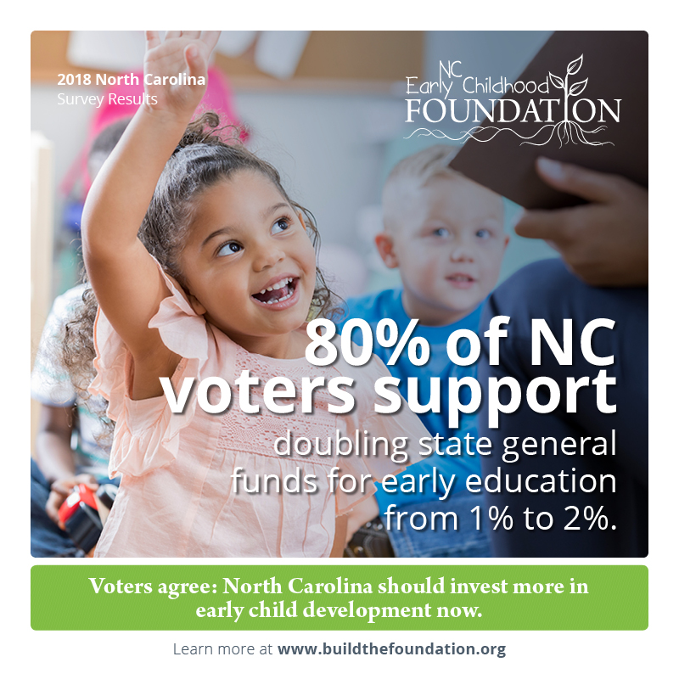

Post 2: A new statewide survey finds that regardless of party lines, North Carolina voters agree that investing in #ECE is more important than reducing business taxes. Want to know more? See the full results at buildthefoundation.org/2018-voter-poll-tookit [Insert graphic]

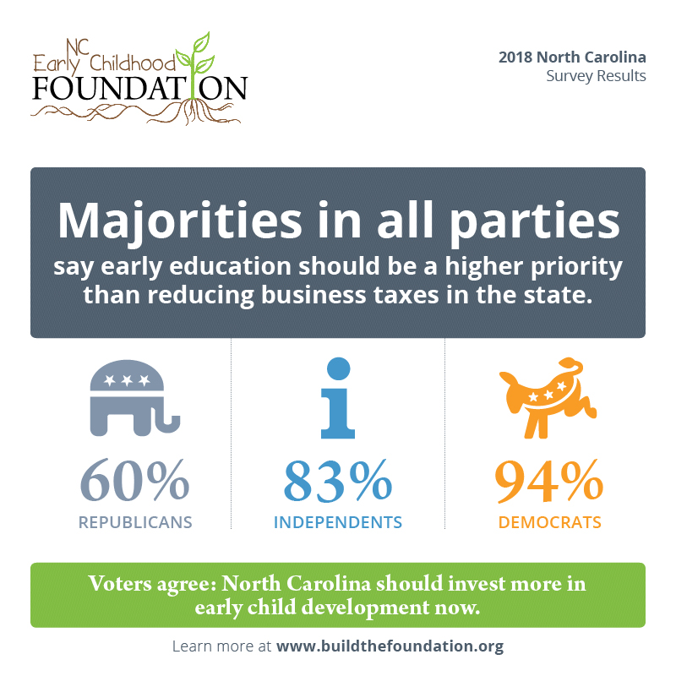

Post 3: NEW DATA: North Carolina voters overwhelmingly agree that we should be doing more to ensure children get a strong start prior to kindergarten. Find all of the results at buildthefoundation.org/2018-voter-poll-tookit [Insert graphic]

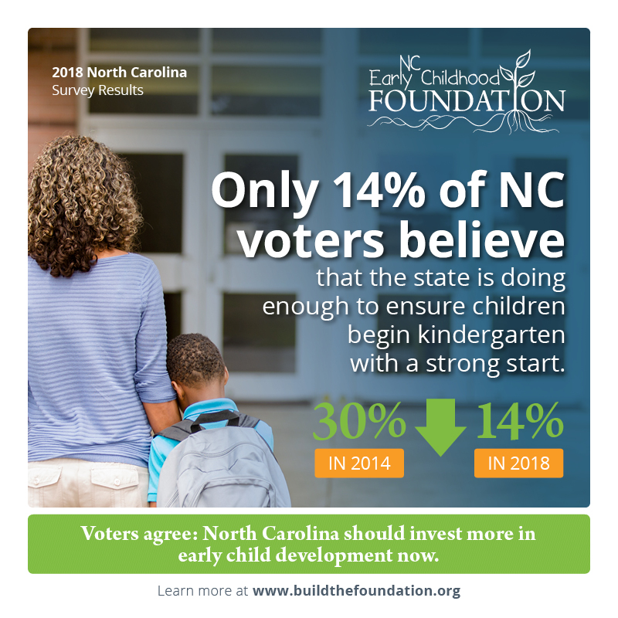

Post 4: NEW POLL: Republicans, Independents and Democrats all agree—North Carolina is not doing enough right now to make sure children begin kindergarten with a strong start. Learn more at buildthefoundation.org/2018-voter-poll-tookit [Insert graphic]

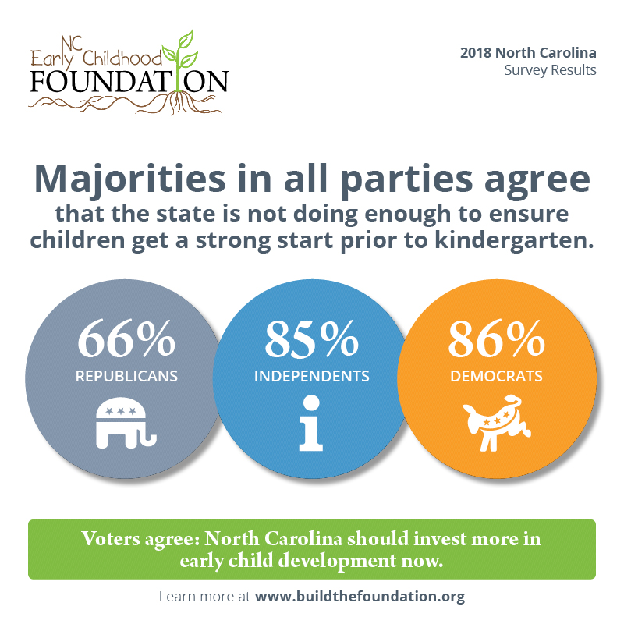

Post 5: New research finds that North Carolina voters favor a range of policies to help families raise healthy babies, including expanded access to home visiting programs. Find all of the results at buildthefoundation.org/2018-voter-poll-tookit [Insert graphic]

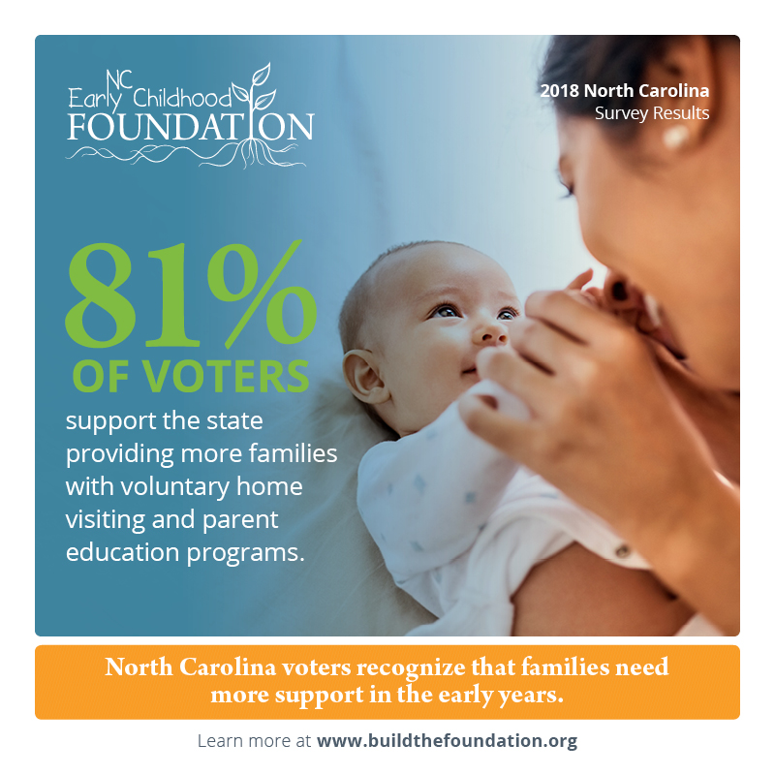

Post 6: A new statewide survey finds that 87% of North Carolinians support paid leave for parents after the birth or adoption of a child. Want to know more? See the full findings at buildthefoundation.org/2018-voter-poll-tookit [Insert graphic]

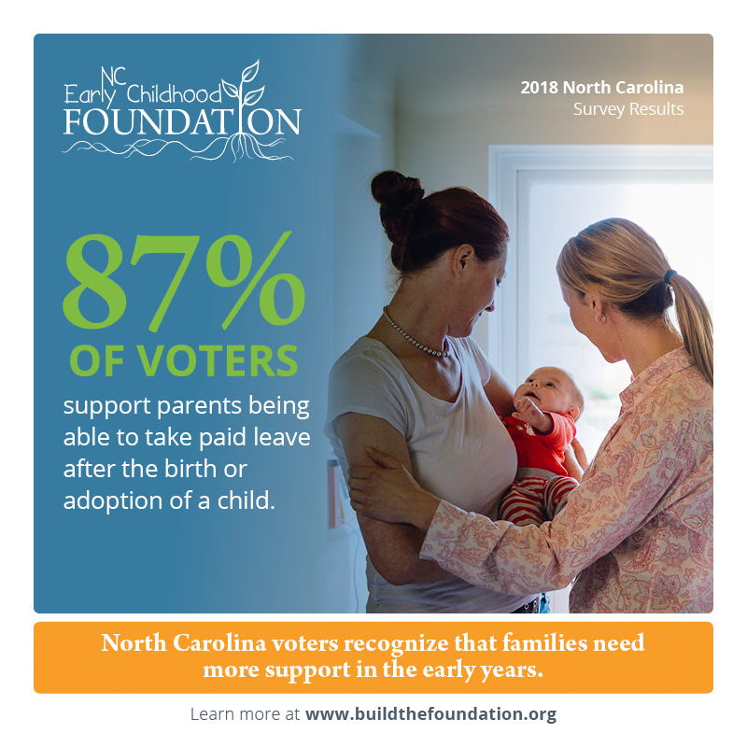

Post 7: NEW POLL: North Carolina voters strongly support expanding NC Pre-K and Smart Start. They know it’s important to provide greater access to affordable, quality #ECE. Want to know more? Find all of the results at buildthefoundation.org/2018-voter-poll-tookit [Insert graphic]

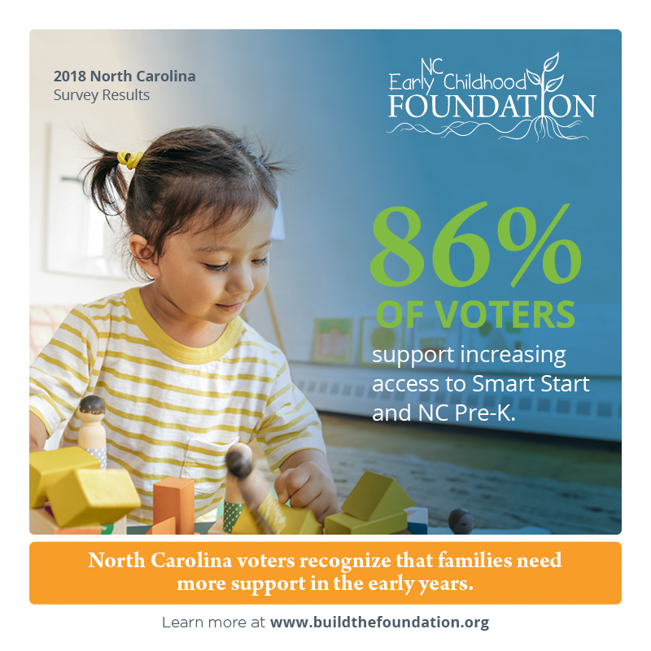

Post 8: #ECE is not a partisan issue. Majorities in all parties support increased access to the state’s early childhood programs, Smart Start and NC Pre-K. Find all of the results at buildthefoundation.org/2018-voter-poll-tookit [Insert graphic]

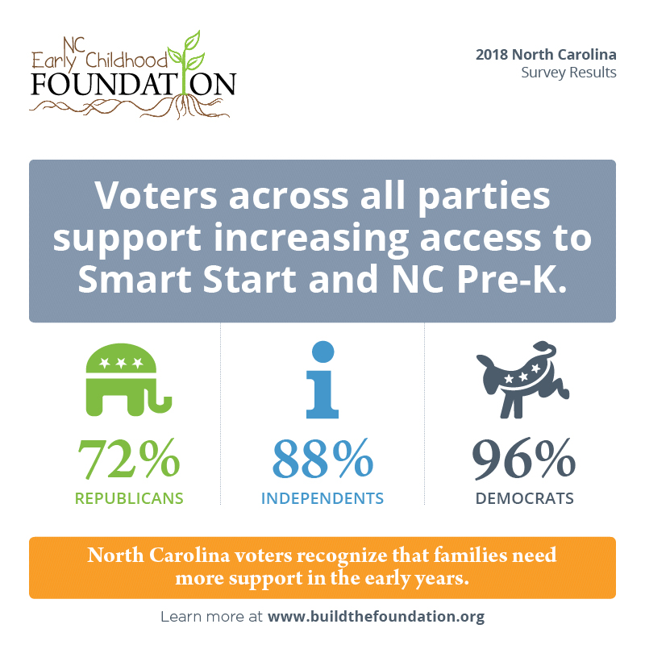

Tweet 1: NEW POLL: Voters across North Carolina are united on making quality, birth-to-age-eight early education a top priority for the state—including doubling investment in #ECE. Want more results? See them here: buildthefoundation.org/2018-voter-poll-tookit [Insert graphic]

Tweet 2: A new statewide survey finds that regardless of party lines, North Carolina voters agree that investing in #ECE is more important than reducing business taxes. Want to know more? See the full results at buildthefoundation.org/2018-voter-poll-tookit [Insert graphic]

Tweet 3: NEW DATA: North Carolina voters overwhelmingly agree that we should be doing more to ensure children get a strong start prior to kindergarten. Find the full results at buildthefoundation.org/2018-voter-poll-tookit [Insert graphic]

Tweet 4: NEW POLL: Republicans, Independents and Democrats all agree—North Carolina is not doing enough right now to make sure children begin kindergarten with a strong start. Learn more at buildthefoundation.org/2018-voter-poll-tookit [Insert graphic]

Tweet 5: New research finds that North Carolina voters favor a range of policies to help families raise healthy babies, including expanded access to home visiting programs. Find all of the results at buildthefoundation.org/2018-voter-poll-tookit [Insert graphic]

Tweet 6: A new statewide survey finds that 87% of North Carolinians support paid leave for parents after the birth or adoption of a child. Want to know more? See the full findings at buildthefoundation.org/2018-voter-poll-tookit [Insert graphic]

Tweet 7: NEW POLL: North Carolina voters strongly support expanding NC Pre-K and Smart Start. They know it’s important to provide greater access to affordable, quality #ECE. Want to know more? Find all of the results at buildthefoundation.org/2018-voter-poll-tookit [Insert graphic]

Tweet 8: #ECE is not a partisan issue. Majorities in all parties support increased access to the state’s early childhood programs, Smart Start and NC Pre-K. Find all of the results at buildthefoundation.org/2018-voter-poll-tookit [Insert graphic]

