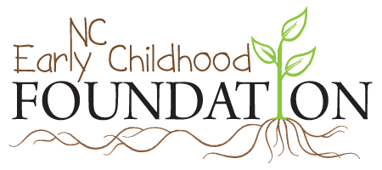

Request for Applications
Early Learning and the Every Student Succeeds Act Collaborative:
Technical Assistance and Coaching
The Every Student Succeeds Act (ESSA) provides new opportunities for school districts to strengthen the birth-through-third grade continuum - a critical strategy to improve third grade reading proficiency.
As Local Education Agencies (LEAs) develop their district ESSA plans for the 2018-19 academic year, they will be required to engage early learning stakeholders. he North Carolina Early Childhood Foundation (NCECF) is partnering with the Department of Public Instruction to support LEAs and early childhood community leaders in collaborating to develop the early learning components of their ESSA district plans. This support includes:
- Building awareness on early learning opportunities in ESSA, how early learning supports district goals, and how to engage the early learning community in district plan development.
- Convening regional meetings of district teams. More than 70 district teams of have registered to attend a regional meeting in January. These meetings will delve deeper into the early learning strategies available to districts, share best practices, highlight using early childhood data to make informed-decisions, and provide time and support for working together on their plans.
- Providing intensive support to a small number of local teams, including coaching, materials, a shared learning community and plan review. Materials and lessons learned will be shared across the state.
This Request for Applications is for intensive support. In addition to the technical assistance described above, selected districts will receive a $1,000 award to support convening stakeholders in their community.
Please note the following:
- Applications will be accepted ONLY from districts that attend a regional meeting.
- Only one application per school district may be submitted.
- Applications can be submitted by the Local Education Agency, Head Start, Smart Start Local Partnership or any other community organization provided that all required signatures are included.
- The team will need to determine which agency will serve as fiscal agent.
- Applications are due by 5 PM, February 2, 2018.
- Applications should be sent via email to ssyed@buildthefoundation.org.

Please provide the following information for the person completing the application.

Name
Title
Organization
Email
Phone Number
School District
Signature

Please provide the following information for the organization that will serve as fiscal agent for the award.
Organization
Contact Name
Address
City, ST, ZIP
Email
Phone Number

On a separate piece of paper, please answer the following questions.
- Has your community had a focus on advancing your birth-to-eight system?
  - If yes, please describe. If no, please skip to question 2.
  - If yes, what has been your greatest achievement in the past two years?
  - What did it take to accomplish this achievement?
  - Who was involved? What was the role of the Local Education Agency? Head Start? Smart Start Local Partnership? Other early learning community stakeholders?
- If you could accomplish one significant achievement to advance your community’s birth-to-eight system in the next two years, what would it be?
- Who will you need to engage to accomplish that achievement, and how will you engage them?
The following signatures are required:

Superintendent
Title 1 Director
Head Start Director
Smart Start Director

